|  |  |
| --- | --- |
| **ASSESSMENT 1 SUBMISSION** | |
| **Module Title:** | Database Modelling |
| **Module Code:** | KC7013 |
| **Academic Year / Semester:** | 2022-23 / Semester 2 |
| **Module Tutor / Email (all queries):** | Akhtar Ali [akhtar.ali@northumbria.ac.uk](mailto:akhtar.ali@northumbria.ac.uk) |
| **% Weighting (to overall module):** | 50% |
| **Assessment Title:** | Assignment 1: Analysis, design and implementation of a relational database |
| **Date of Handout to Students:** | 7th February 2023 |
| **Mechanism for Handout:** | Module Blackboard Site & Live Session in Week 3 |
| **Deadline for Submission Attempt by Students:** | Thursday 16th March 2023 @ 23:59 |
| **Mechanism for Submission:** | Document upload to Module Blackboard Site |
| **Submission Format / Word Count** | Please upload your written report as a single PDF document |
| **Date by which Work, Feedback and Marks will be returned:** | Week commencing 17th April 2023 |
| **Mechanism for return of Feedback and Marks:** | Mark and individual written feedback will be uploaded to the Module Site on Blackboard. For further queries please email module tutor. |
| **Student ID/ Oracle Username** | W22046071/dbmUsr91 |
| **Student Name** | Rabbani Yakhubji |

**ASSIGNMENT # 1**

**Personalising your SQL output/prompt**

Before executing any **SQL code** for this assignment, you should personalise your SQL output / prompt by running SET SQLPROMPT “UniversityUserName > ”, i.e., *double-quote* followed by your UniversityUserName followed by > and then a *space* and *double-quote* as shown in the screenshot below:

**Assignment Questions**

**Part 1 (50 marks)**

*(A) Using a database design approach of your choice, produce a logical design for the database to support the information system, which is needed at* *NorthEastNinjas.*

(25 marks)

Your answer must consist of ONE of the following:

* *An entity-relationship (ER) diagram (15 marks) and its mapping into a set of relations (10 marks). The ER diagram should show all relevant entity types, relationship types, attributes, keys, and structural constraints. Note that not all keys are identified/mentioned in the scenario, so you are required to identify/devise appropriate keys for all the entity types. Your ER diagram must not show any foreign keys.*

*As part of the mapping process, for each relation, you should identify appropriate primary keys as well as foreign keys (if applicable). Furthermore, you need to make sure your relations obtained from mapping your ER diagram are in 3rd normal form.*

* *A set of normalised relations (10 marks) obtained through applying the normalisation process (15 marks) instead of ER modelling. You should make clear how the normalisation process has been carried out, and the reasoning employed, in particular quoting evidence (series of steps) to support the decisions made and how various relations have been derived. Each relation in your answer should be in 3rd normal form.*

Answer Part 1 A:

ER Diagram (15 marks)

and

ER Diagram to Relations Mapping to obtain normalised relations (10 marks)

ER diagram

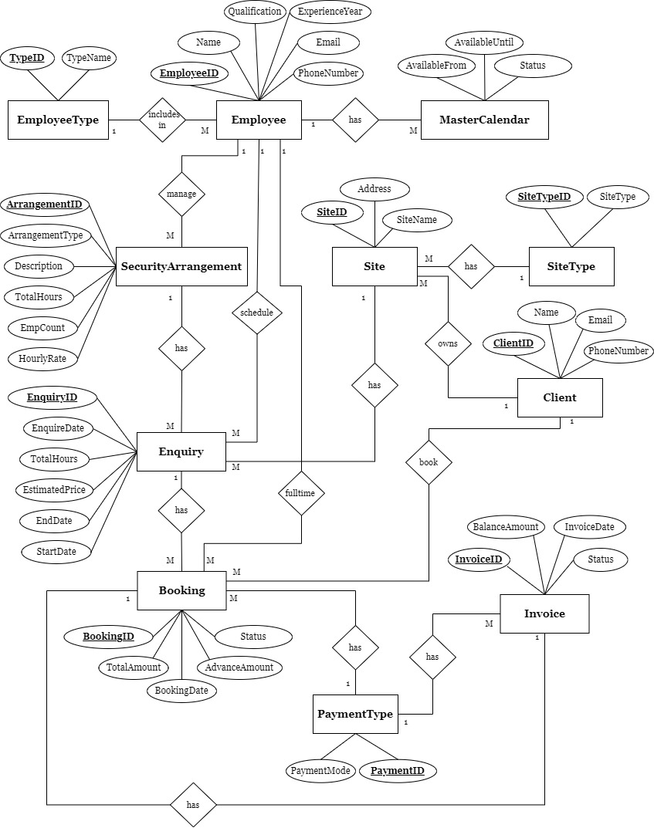

ER diagram to relational mapping

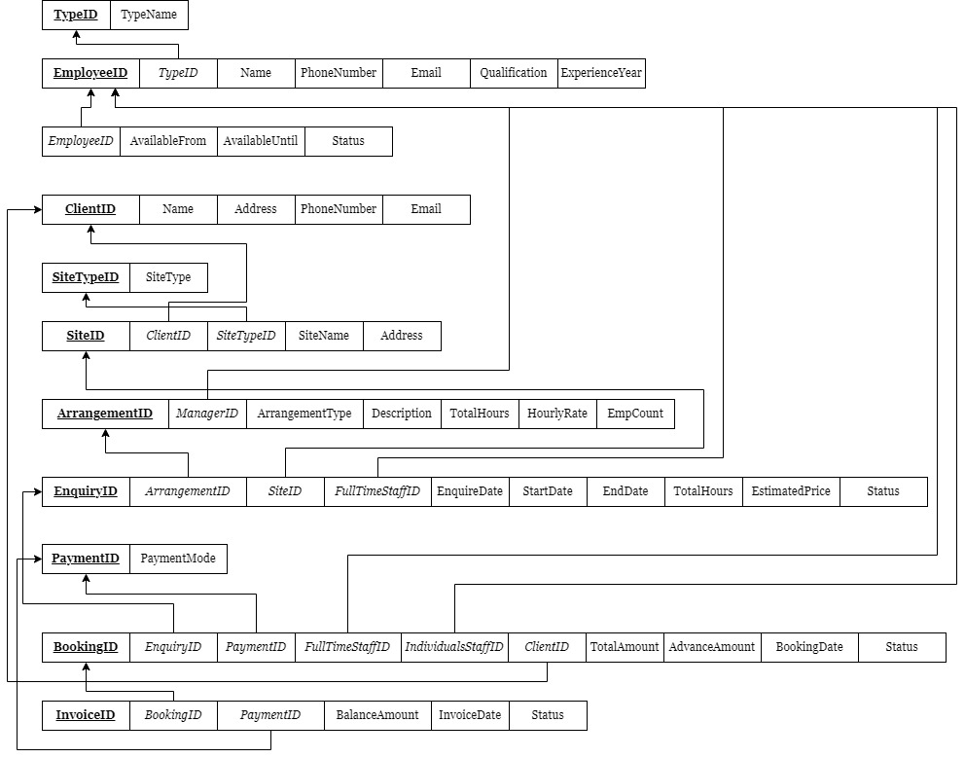

OR

Steps of your Normalisation process (15 marks)

and

set of Normalised Relations (10 marks)

1. *You need to research, choose and justify an appropriate naming convention for relations, attributes, and keys. You need to use your chosen convention consistently throughout your assignment. You need to document all elements of your logical relational design / schema in a data dictionary, in a tabular form and must be presented as text rather than an image or picture. The data dictionary should include all relevant names, descriptions and constraints.*

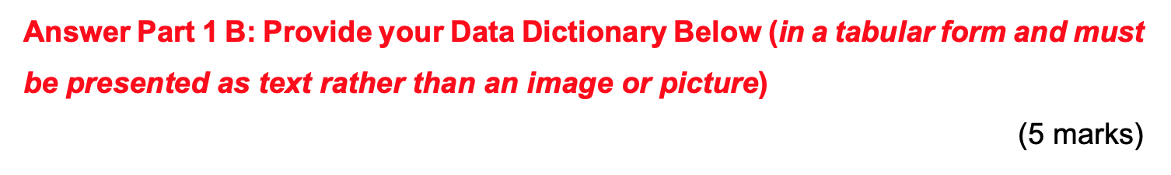

|  |  |  |  |
| --- | --- | --- | --- |
| Name of the table | Name of the attribute | Data type | Key constraint |
| EmployeeType | TypeID | INT | Primary key |
| TypeName | VARCHAR(20) |  |
| Employees | EmployeeID | INT | Primary key |
| TypeID | INT | Foreign key |
| Name | VARCHAR(20) |  |
| PhoneNumber | INT |  |
| Email | VARCHAR(30) |  |
| Qualification | VARCHAR(20) |  |
| ExperienceYear | INT |  |
| MasterCalendar | EmployeeID | INT | Foreign key |
| AvailableFrom | DATE |  |
| AvailableUntil | DATE |  |
| Status | VARCHAR(20) |  |
| Client | ClientID | INT | Primary key |
| Name | VARCHAR(20) |  |
| Address | VARCHAR(20) |  |
| PhoneNumber | INT |  |
| Email | VARCHAR(30) |  |
| SiteType | SiteTypeID | INT | Primary key |
| SiteType | VARCHAR(20) |  |
| Site | SiteID | INT | Primary key |
| ClientID | INT | Foreign key |
| SiteTypeID | INT | Foreign key |
| SiteName | VARCHAR(20) |  |
| Address | VARCHAR(20) |  |
| SecurityArrangement | ArrangementID | INT | Primary key |
| ManagerID | INT | Foreign key |
| ArrangementType | VARCHAR(20) |  |
| Description | VARCHAR(40) |  |
| TotalHours | INT |  |
| HourlyRate | DECIMAL(5,2) |  |
| EmpCount | INT |  |
| Enquiry | EnquiryID | INT | Primary key |
| SiteID | INT | Foreign key |
| ArrangementID | INT | Foreign key |
| FullTimeStaffID | INT | Foreign key |
| EnquireDate | DATE |  |
| StartDate | DATE |  |
| EndDate | DATE |  |
| TotalHours | INT |  |
| EstimatedPrice | DECIMAL(5,2) |  |
| Status | VARCHAR(20) |  |
| PaymentType | PaymentID | INT | Primary key |
| PaymentMode | VARCHAR(20) |  |
| Booking | BookingID | INT | Primary key |
| EnquiryID | INT | Foreign key |
| FullTimeStaffID | INT | Foreign key |
| IndividualsStaffID | INT | Foreign key |
| ClientID | INT | Foreign key |
| PaymentID | INT | Foreign key |
| TotalAmount | DECIMAL(5,2) |  |
| AdvanceAmount | DECIMAL(5,2) |  |
| BookingDate | DATE |  |
| Status | VARCHAR(20) |  |
| Invoice | InvoiceID | INT | Primary key |
| BookingID | INT | Foreign key |
| PaymentID | INT | Foreign key |
| BalanceAmount | DECIMAL(5,2) |  |
| InvoiceDate | DATE |  |
| Status | VARCHAR(20) |  |

*(C) Based on your logical design from Part 1 (A) and the data dictionary from Part 1 (B), and the information available in the scenario, produce an SQL script file using Oracle 11g/12c/19c.*

(20 marks)

Answer Part 1 C: SQL DDL Script file contents [make sure it is TEXT rather than image or screenshot]: 20 marks

CREATE TABLE EmployeeType(

TypeID INT NOT NULL,

TypeName VARCHAR(20),

PRIMARY KEY(TypeID)

);

CREATE TABLE Employees(

EmployeeID INT NOT NULL,

TypeID INT NOT NULL,

Name VARCHAR(20),

PhoneNumber INT NOT NULL,

Email VARCHAR(30),

Qualification VARCHAR(20),

ExperienceYear INT,

PRIMARY KEY(EmployeeID),

FOREIGN KEY(TypeID) REFERENCES EmployeeType(TypeID)

);

CREATE TABLE MasterCalendar(

EmployeeID INT NOT NULL,

AvailableFrom DATE,

AvailableUntil DATE,

Status VARCHAR(20),

FOREIGN KEY(EmployeeID) REFERENCES Employees(EmployeeID)

);

CREATE TABLE Client(

ClientID INT NOT NULL,

Name VARCHAR(20),

Address VARCHAR(20),

PhoneNumber INT,

Email VARCHAR(30),

PRIMARY KEY(ClientID)

);

CREATE TABLE SiteType(

SiteTypeID INT NOT NULL,

SiteType VARCHAR(20),

PRIMARY KEY(SiteTypeID)

);

CREATE TABLE Site(

SiteID INT NOT NULL,

ClientID INT NOT NULL,

SiteTypeID INT NOT NULL,

SiteName VARCHAR(20),

Address VARCHAR(20),

PRIMARY KEY(SiteID),

FOREIGN KEY(ClientID) REFERENCES Client(ClientID),

FOREIGN KEY(SiteTypeID) REFERENCES SiteType(SiteTypeID)

);

CREATE TABLE SecurityArrangement(

ArrangementID INT NOT NULL,

ManagerID INT NOT NULL,

ArrangementType VARCHAR(20),

Description VARCHAR(40),

TotalHours INT NOT NULL,

HourlyRate DECIMAL(5,2),

EmpCount INT NOT NULL,

PRIMARY KEY(ArrangementID),

FOREIGN KEY(ManagerID) REFERENCES Employees(EmployeeID)

);

CREATE TABLE Enquiry(

EnquiryID INT NOT NULL,

SiteID INT NOT NULL,

ArrangementID INT NOT NULL,

FullTimeStaffID INT NOT NULL,

EnquireDate DATE,

StartDate DATE,

EndDate DATE,

TotalHours INT NOT NULL,

EstimatedPrice DECIMAL(5,2),

Status VARCHAR(20),

PRIMARY KEY(EnquiryID),

FOREIGN KEY(SiteID) REFERENCES Site(SiteID),

FOREIGN KEY(ArrangementID) REFERENCES SecurityArrangement(ArrangementID),

FOREIGN KEY(FullTimeStaffID) REFERENCES Employees(EmployeeID)

);

CREATE TABLE PaymentType(

PaymentID INT NOT NULL,

PaymentMode VARCHAR(20),

PRIMARY KEY(PaymentID)

);

CREATE TABLE Booking(

BookingID INT NOT NULL,

EnquiryID INT NOT NULL,

FullTimeStaffID INT NOT NULL,

IndividualsStaffID INT NOT NULL,

ClientID INT NOT NULL,

PaymentID INT NOT NULL,

TotalAmount DECIMAL(5,2),

AdvanceAmount DECIMAL(5,2),

BookingDate DATE,

Status VARCHAR(20),

PRIMARY KEY(BookingID),

FOREIGN KEY(EnquiryID) REFERENCES Enquiry(EnquiryID),

FOREIGN KEY(FullTimeStaffID) REFERENCES Employees(EmployeeID),

FOREIGN KEY(individualsStaffID) REFERENCES Employees(EmployeeID),

FOREIGN KEY(clientID) REFERENCES Client(clientID),

FOREIGN KEY(PaymentID) REFERENCES PaymentType(PaymentID)

);

CREATE TABLE Invoice(

InvoiceID INT NOT NULL,

BookingID INT NOT NULL,

PaymentID INT NOT NULL,

BalanceAmount DECIMAL(5,2),

InvoiceDate DATE,

Status VARCHAR(20),

PRIMARY KEY(InvoiceID),

FOREIGN KEY(BookingID) REFERENCES Booking(BookingID),

FOREIGN KEY(PaymentID) REFERENCES PaymentType(PaymentID)

);

Answer Part 1 C: SQL DDL Output (e.g., SPOOL file contents or output you got when you executed your above SQL Table creation / alteration code, this should show the SQL code as well as its output / result). Make sure the output is NOT TEXT but rather images or screenshots.

If missing or inadequate, then up to 4 marks will be deducted from the above 20 marks for this Part 1 C.

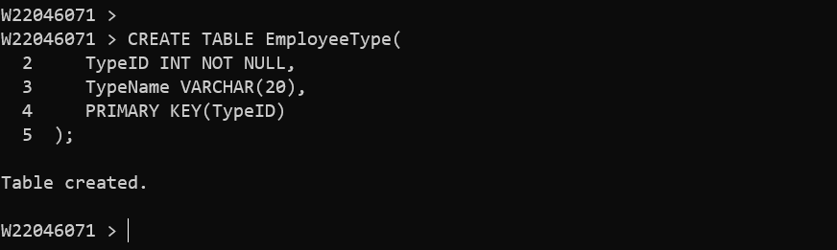

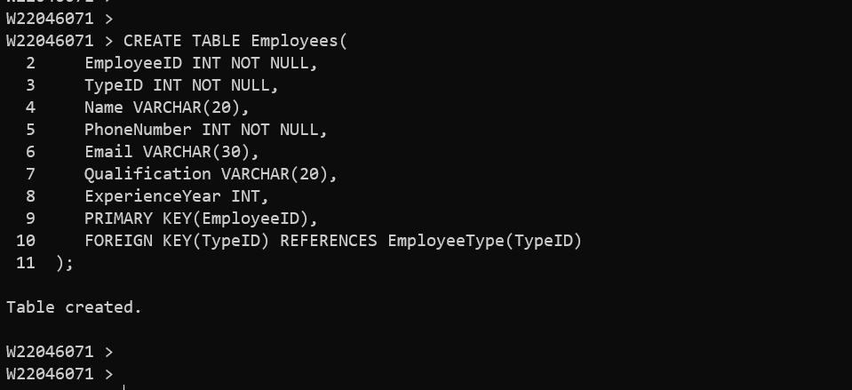

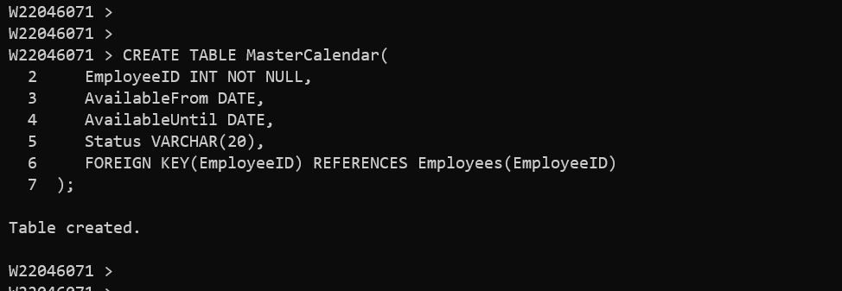

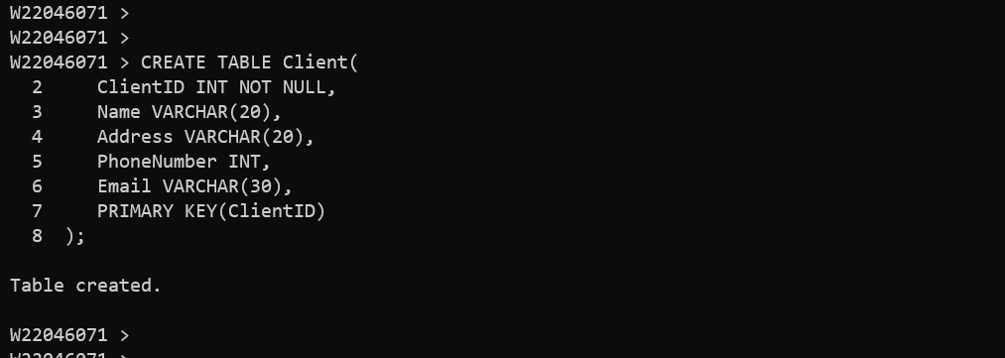

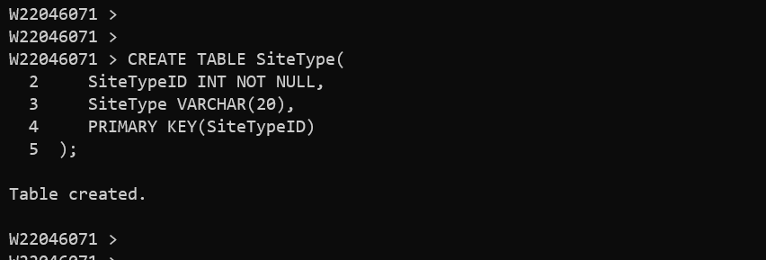

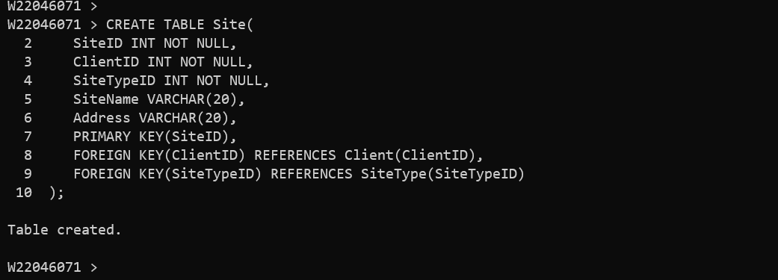

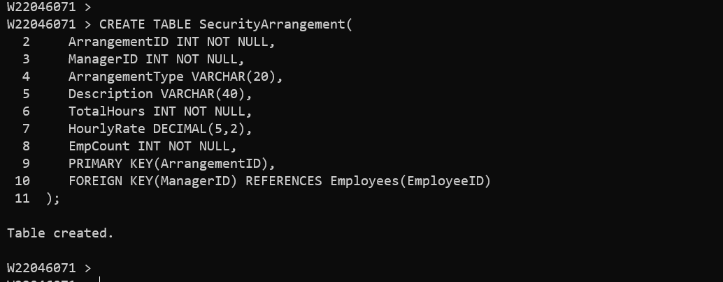

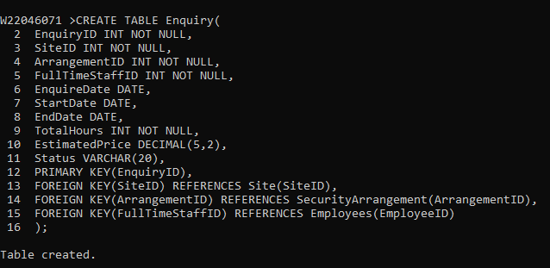

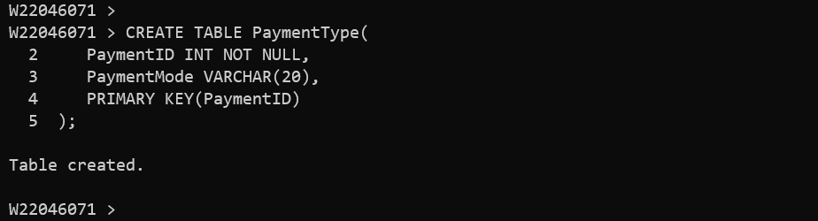

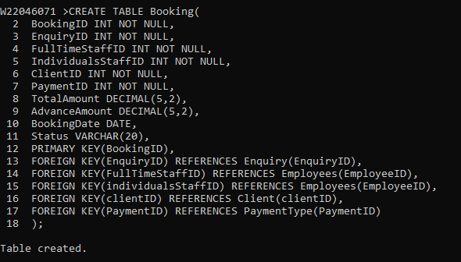

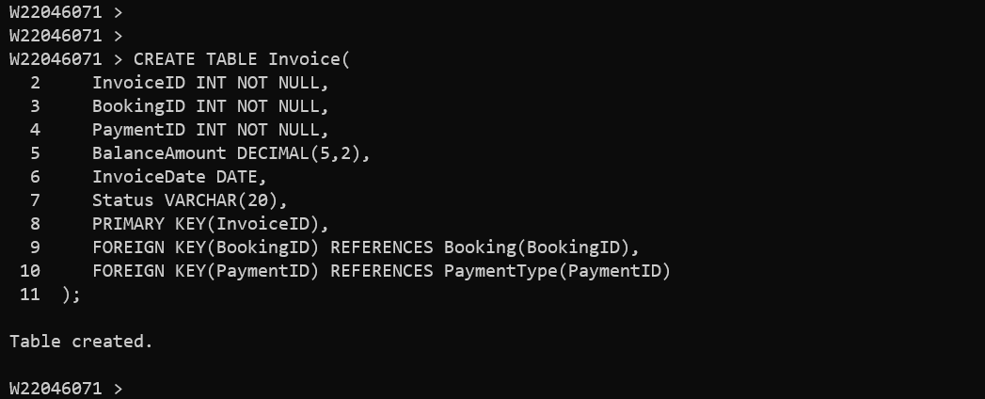

**Part 2 (30 marks)**

*(A) Populate the NorthEastNinjas database with some data (e.g., you should generate your own dummy data and load it into the NorthEastNinjas database, consider 5 to 10 rows for each table and enough data to see meaningful output for the queries below)*.

(10 marks)

Answer Part 2 A: SQL code for populating the NorthEastNinjas database [this should be simple TEXT and not image or screenshot]: 10 marks

INSERT INTO EmployeeType VALUES (1, 'Full Time');

INSERT INTO EmployeeType VALUES (2, 'Individuals');

INSERT INTO EmployeeType VALUES (3, 'Managers');

INSERT INTO EmployeeType VALUES (4, 'Individuals');

INSERT INTO EmployeeType VALUES (5, 'Full Time');

INSERT INTO EmployeeType VALUES (6, 'Managers');

INSERT INTO EmployeeType VALUES (7, 'Full Time');

INSERT INTO EmployeeType VALUES (8, 'Full Time');

INSERT INTO EmployeeType VALUES (9, 'Managers');

INSERT INTO EmployeeType VALUES (10, 'Individuals');

INSERT INTO Employees VALUES (1, 1, 'Yakhubji', 123456789, 'yakhubji@gmail.com', 'MBA', 5);

INSERT INTO Employees VALUES (2, 2, 'Shahid', 987654321, 'shahid@gmail.com', 'B.Sc.', 10);

INSERT INTO Employees VALUES (3, 1, 'Irfan', 789456321, 'irfan@gmail.com', 'M.Tech', 8);

INSERT INTO Employees VALUES (4, 2, 'Arif', 124567890, 'arif@gmail.com', 'M.Sc.', 3);

INSERT INTO Employees VALUES (5, 3, 'Inthiyaz', 321456709, 'inthiyaz@gmail.com', 'B.Tech', 4);

INSERT INTO Employees VALUES (6, 1, 'Ghouse', 543219876, 'ghouse@gmail.com', 'MBA', 2);

INSERT INTO Employees VALUES (7, 3, 'Jeelan', 908765432, 'jeelan@gmail.com', 'B.Sc.', 6);

INSERT INTO Employees VALUES (8, 2, 'Vahid', 765432109, 'vahid@gmail.com', 'M.Sc.', 7);

INSERT INTO Employees VALUES (9, 3, 'Mainu', 876543210, 'mainu@gmail.com', 'B.Tech', 9);

INSERT INTO Employees VALUES (10, 1, 'Kasif', 654321987, 'kasif@gmail.com', 'MBA', 1);

INSERT INTO MasterCalendar VALUES (4, '01-JUN-2023', '19-JULY-2023', 'Vacation');

INSERT INTO MasterCalendar VALUES (2, '20-MAR-2023', '05-APR-2023', 'Not available');

INSERT INTO MasterCalendar VALUES (3, '15-MAY-2023', '23-JUN-2023', 'Available');

INSERT INTO MasterCalendar VALUES (1, '05-SEP-2023', '04-OCT-2023', 'Working');

INSERT INTO MasterCalendar VALUES (5, '11-JUN-2023', '07-JULY-2023', 'Vacation');

INSERT INTO MasterCalendar VALUES (8, '07-MAY-2023', '12-JUN-2023', 'Not available');

INSERT INTO MasterCalendar VALUES (9, '16-FEB-2023', '24-APR-2023', 'Available');

INSERT INTO MasterCalendar VALUES (2, '24-JAN-2023', '20-MAY-2023', 'Working');

INSERT INTO Client VALUES (1, 'Shaiksha', '36 Rowland Rd', 07061188519, 'shaiksha@gmail.com');

INSERT INTO Client VALUES (2, 'Shahul', '41 Stone Cellar Road', 07017170994, 'shahul@gmail.com');

INSERT INTO Client VALUES (3, 'Nikith', '25 Withers Close', 0708544795, 'davewilson@gmail.com');

INSERT INTO Client VALUES (4, 'Aadhira', '59 Henley Road', 07858417732, 'aadhira@gmail.com');

INSERT INTO Client VALUES (5, 'Jagath', '38 Earls Avenue', 07069616402, 'jagath@gmail.com');

INSERT INTO Client VALUES (6, 'Loshith', '45 Park End St', 07038550069, 'loshith@gmail.com');

INSERT INTO Client VALUES (7, 'Nithin', '16 Fulford Road', 07917388035, 'nithin@gmail.com');

INSERT INTO Client VALUES (8, 'Saswin', '55 Tonbridge Rd', 07933281321, 'saswin@gmail.com');

INSERT INTO SiteType VALUES (1, 'Property');

INSERT INTO SiteType VALUES (2, 'Business Premises');

INSERT INTO SiteType VALUES (3, 'Construction');

INSERT INTO SiteType VALUES (4, 'Industrial');

INSERT INTO SiteType VALUES (5, 'Private Individual');

INSERT INTO SiteType VALUES (6, 'Private Business');

INSERT INTO SiteType VALUES (7, 'Personal');

INSERT INTO SiteType VALUES (8, 'Commercial');

INSERT INTO Site VALUES (1, 1, 1, 'Wonderful Homes', 'Newcastle upon Tyne');

INSERT INTO Site VALUES (2, 1, 2, 'Luxury Ohio', 'Newcastle upon Tyne');

INSERT INTO Site VALUES (3, 2, 3, 'Texas Waterfront', 'Newcastle upon Tyne');

INSERT INTO Site VALUES (4, 3, 4, 'Sarah Sells Homes', 'Newcastle upon Tyne');

INSERT INTO Site VALUES (5, 4, 1, 'Tom Smith Realty', 'Newcastle upon Tyne');

INSERT INTO Site VALUES (6, 5, 2, 'Johnand Jacob Realty', '7 Whatlington Road');

INSERT INTO Site VALUES (7, 6, 3, 'Anderson Realty', '50 Withers Close');

INSERT INTO Site VALUES (8, 7, 4, 'BuyHome4 Family', '80 Nether Crescent');

INSERT INTO SecurityArrangement VALUES (1, 5, 'Weekdays only', 'Security for the office', 80, 10.00, 5);

INSERT INTO SecurityArrangement VALUES (2, 7, 'Weekend only', 'Security for the entrance', 48, 8.00, 2);

INSERT INTO SecurityArrangement VALUES (3, 9, 'Weekdays and weekend', 'Security for the parking lot', 128, 12.00, 7);

INSERT INTO SecurityArrangement VALUES (4, 5, 'Weekdays only', 'Security for the main gate', 80, 10.50, 5);

INSERT INTO SecurityArrangement VALUES (5, 7, 'Weekend only', 'Security for the reception area', 48, 7.50, 2);

INSERT INTO SecurityArrangement VALUES (6, 9, 'Weekdays and weekend', 'Security for the storeroom', 128, 11.50, 7);

INSERT INTO SecurityArrangement VALUES (7, 7, 'Weekdays only', 'Security for the building', 80, 9.75, 5);

INSERT INTO SecurityArrangement VALUES (8, 5, 'Weekend only', 'Security for the conference room', 48, 8.25, 2);

INSERT INTO Enquiry VALUES (1, 3, 5, 6, '01-MAR-2023', '15-MAR-2023', '01-APR-2023', 160, 160.00, 'Active');

INSERT INTO Enquiry VALUES (2, 4, 8, 10, '25-JAN-2023', '01-FEB-2023', '15-APR-2023', 240, 240.00, 'Active');

INSERT INTO Enquiry VALUES (3, 2, 8, 3, '20-JUL-2023', '25-JUL-2023', '20-AUG-2023', 120, 120.00, 'Inactive');

INSERT INTO Enquiry VALUES (4, 1, 5, 1, '04-MAR-2023', '10-MAY-2023', '15-JUN-2023', 160, 160.00, 'Active');

INSERT INTO Enquiry VALUES (5, 2, 3, 10, '04-APR-2023', '20-APR-2023', '01-JUL-2023', 160, 160.00, 'Inactive');

INSERT INTO Enquiry VALUES (6, 4, 4, 10, '02-FEB-2023', '12-FEB-2023', '15-MAR-2023', 160, 160.00, 'Active');

INSERT INTO PaymentType VALUES (1, 'Credit card');

INSERT INTO PaymentType VALUES (2, 'Cash');

INSERT INTO PaymentType VALUES (3, 'Cheque');

INSERT INTO Booking VALUES (1, 4, 1, 2, 3, 1, 150.00, 25.00, '14-MAR-2023', 'Advance Paid');

INSERT INTO Booking VALUES (2, 1, 3, 4, 5, 1, 200.00, 40.00, '15-APR-2023', 'Booked');

INSERT INTO Booking VALUES (3, 6, 6, 8, 6, 2, 320.00, 60.00, '10-JAN-2023', 'Advance Paid');

INSERT INTO Booking VALUES (4, 2, 10, 2, 4, 1, 175.00, 30.00, '12-FEB-2023', 'Booked');

INSERT INTO Booking VALUES (5, 1, 3, 4, 3, 3, 350.00, 70.00, '18-JAN-2023', 'Advance Paid');

INSERT INTO Booking VALUES (6, 5, 6, 8, 5, 1, 300.00, 50.00, '14-MAR-2023', 'Booked');

INSERT INTO Booking VALUES (7, 6, 1, 8, 6, 2, 400.00, 85.00, '11-FEB-2023', 'Advance Paid');

INSERT INTO Booking VALUES (8, 2, 3, 4, 4, 1, 250.00, 40.00, '16-FEB-2023', 'Booked');

INSERT INTO Booking VALUES (9, 1, 10, 2, 3, 3, 500.00, 100.00, '20-FEB-2023', 'Advance Paid');

INSERT INTO Invoice VALUES (1, 2, 1, 50.00, '18-APR-2023', 'Fully Paid');

INSERT INTO Invoice VALUES (2, 1, 2, 40.00, '17-MAR-2023', 'Fully Paid');

INSERT INTO Invoice VALUES (3, 5, 3, 25.00, '22-JAN-2023', 'Fully Paid');

INSERT INTO Invoice VALUES (4, 9, 1, 70.00, '27-FEB-2023', 'Fully Paid');

INSERT INTO Invoice VALUES (5, 4, 2, 50.00, '15-FEB-2023', 'Fully Paid');

INSERT INTO Invoice VALUES (6, 7, 3, 30.00, '19-FEB-2023', 'Fully Paid');

INSERT INTO Invoice VALUES (7, 8, 1, 60.00, '17-FEB-2023', 'Fully Paid');

INSERT INTO Invoice VALUES (8, 3, 2, 40.00, '25-JAN-2023', 'Fully Paid');

INSERT INTO Invoice VALUES (9, 6, 3, 35.00, '20-MAR-2023', 'Fully Paid');

Answer Part 2 A: Output of SQL code for populating the database (e.g., SPOOL file contents or output you got when you executed your above SQL code, this should show the SQL code as well as its output / result). Make sure the output is NOT TEXT but rather images or screenshots.

If missing or inadequate, then up to 2 marks will be deducted from the above 10 marks for this Part 2 A.

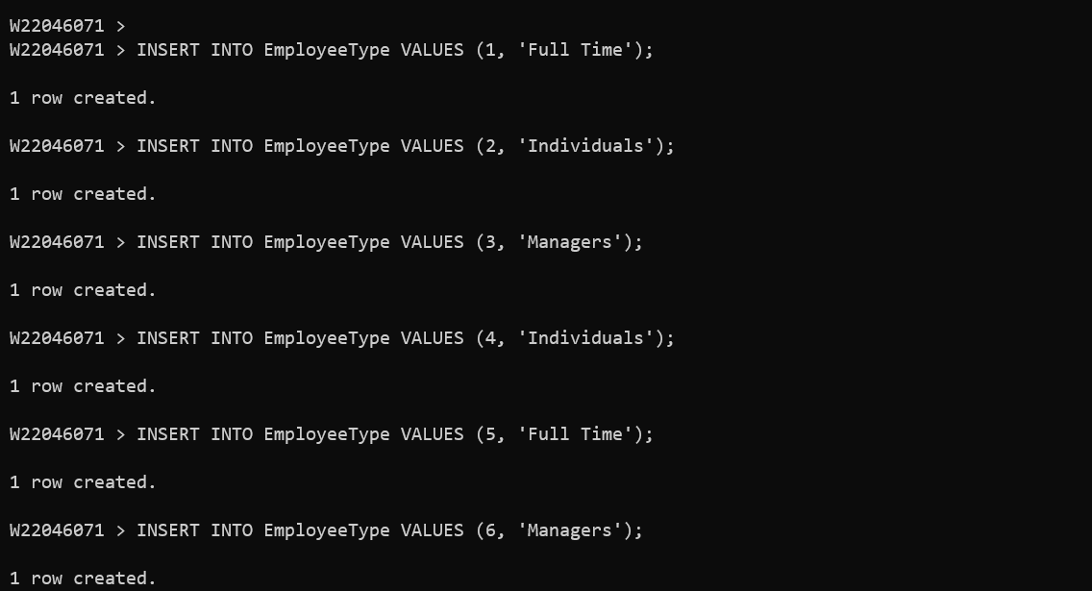

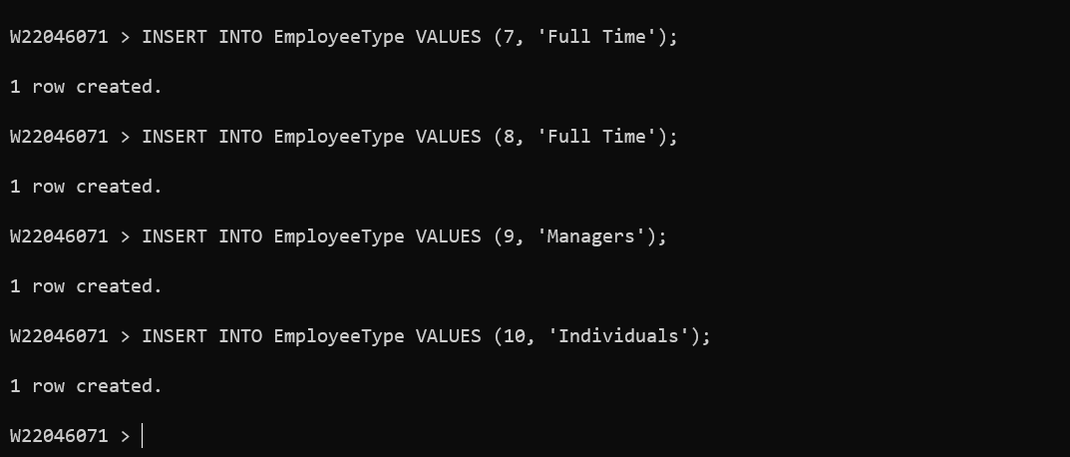

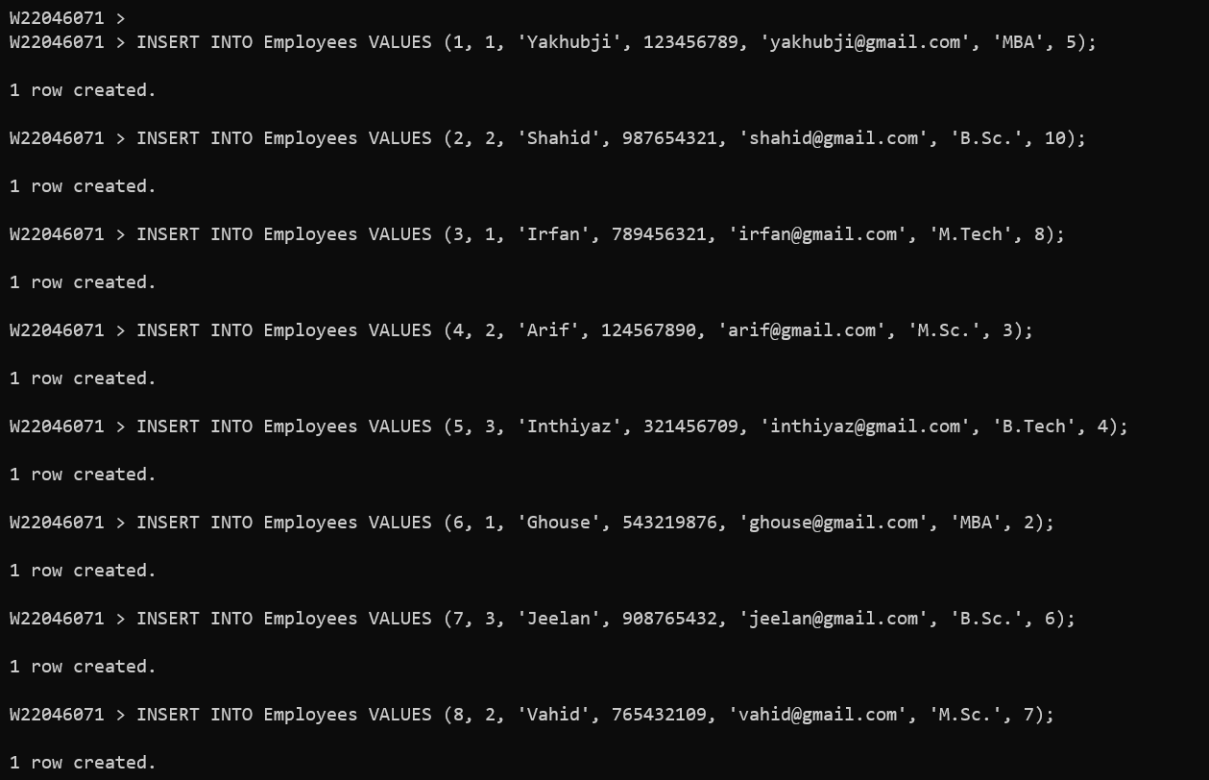

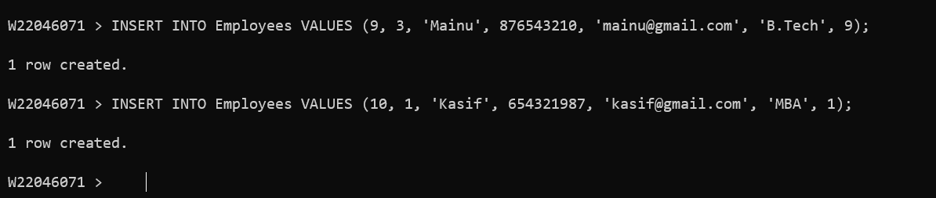

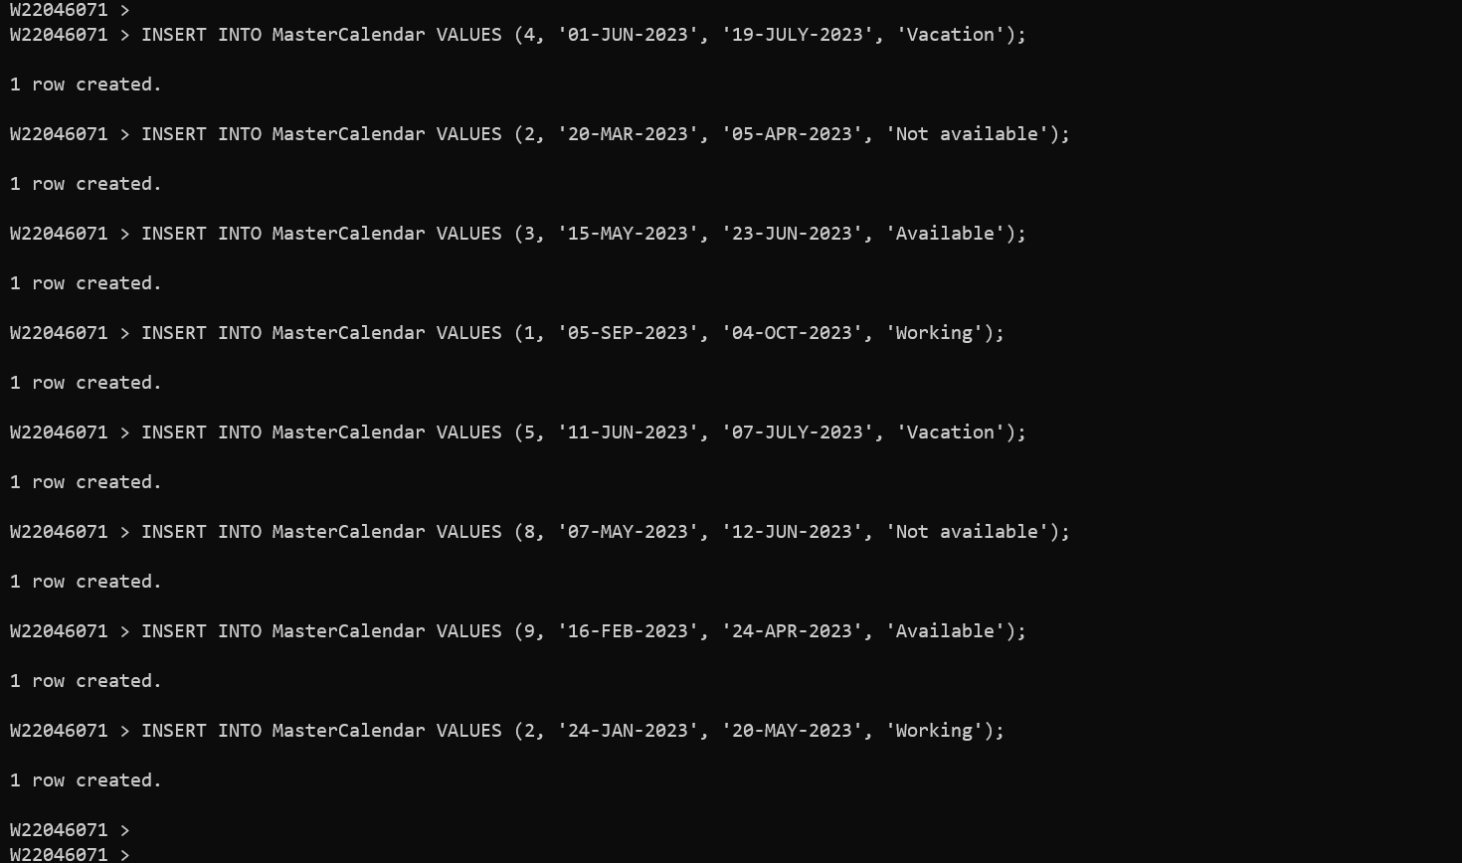

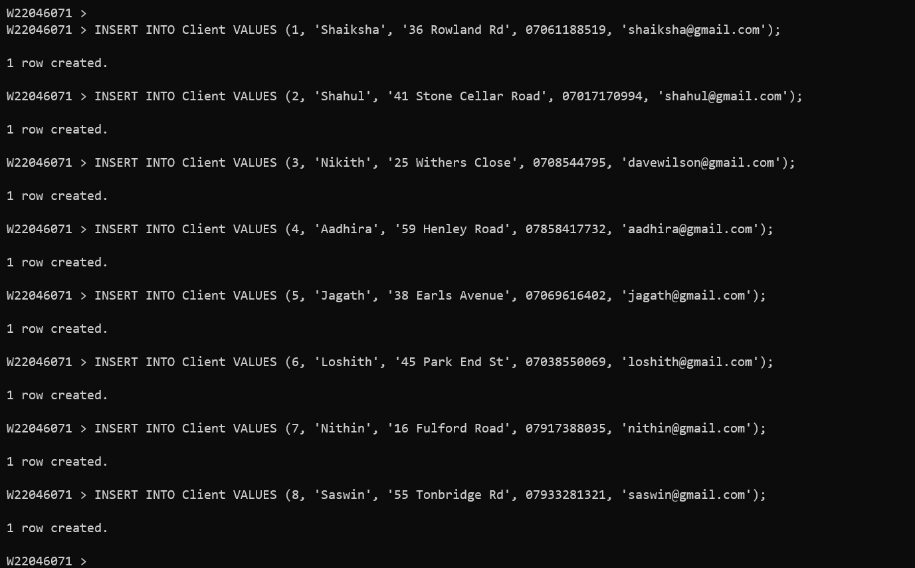

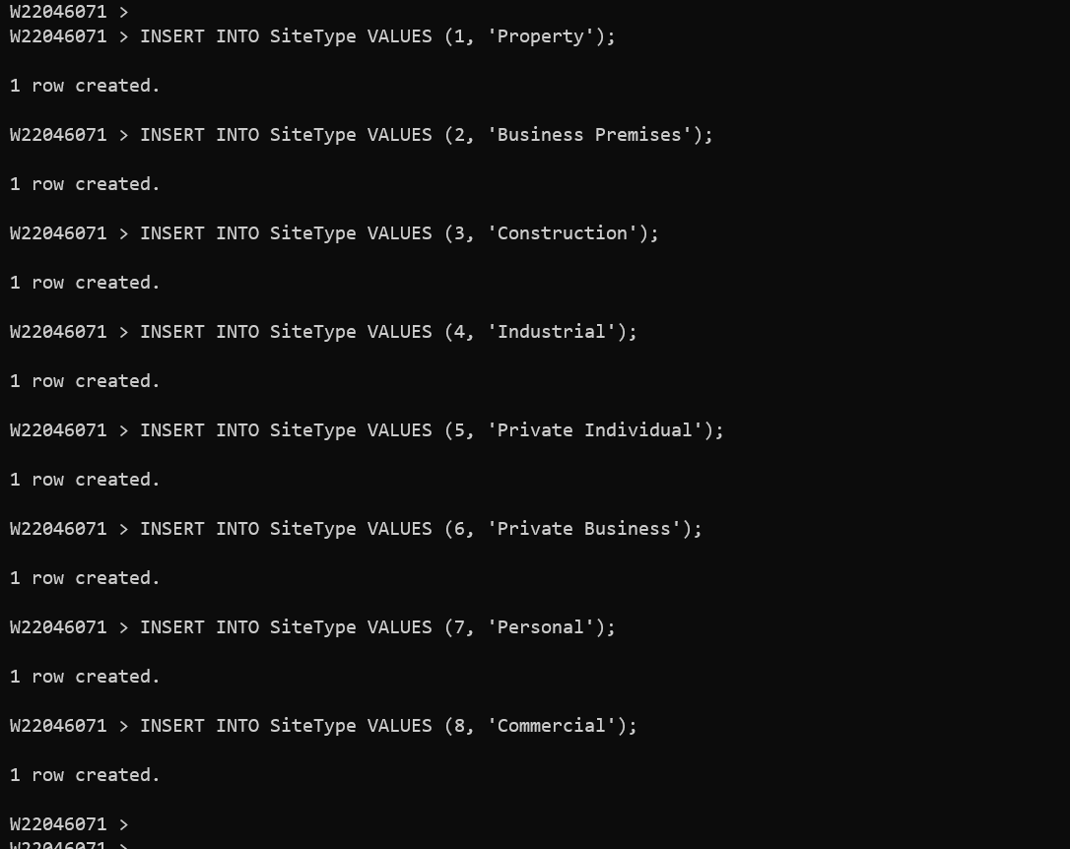

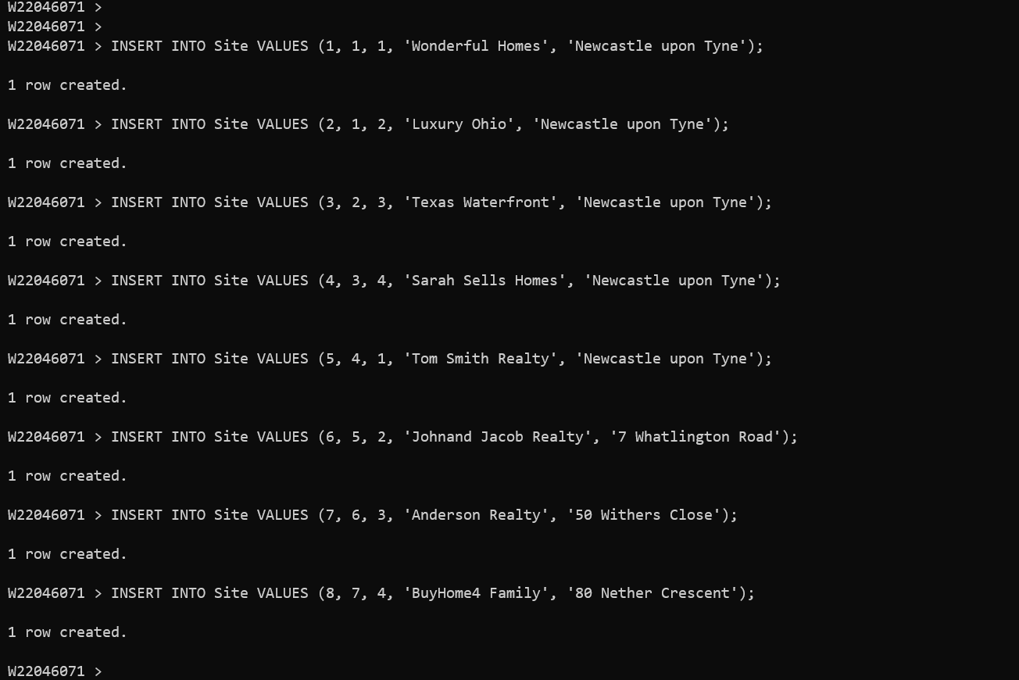

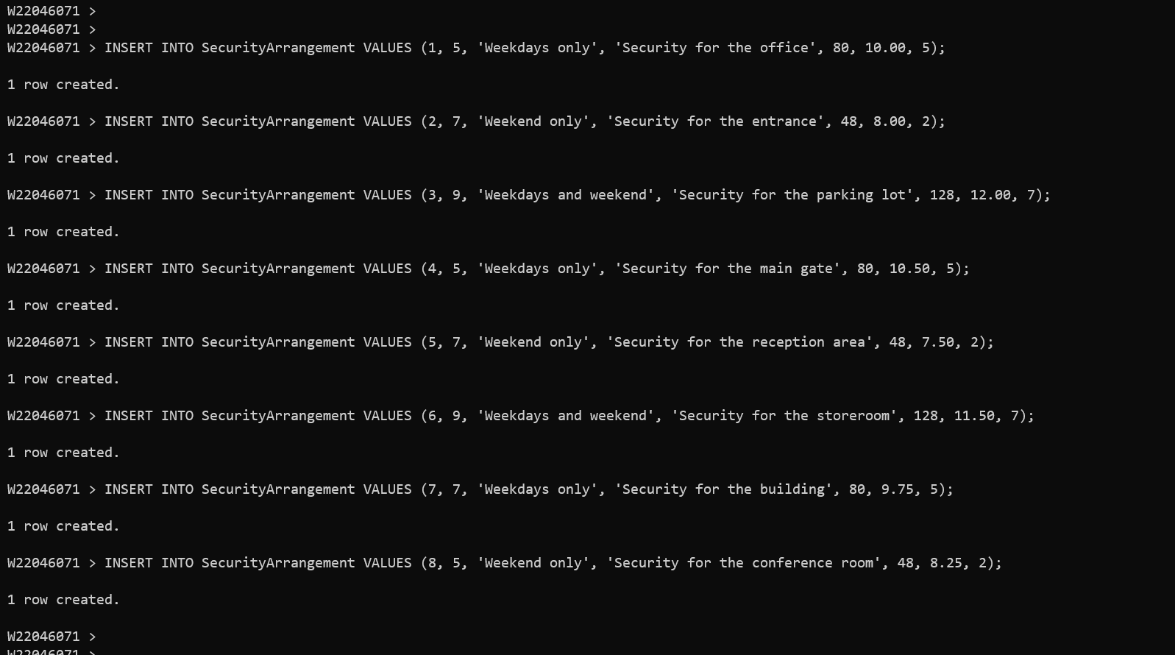

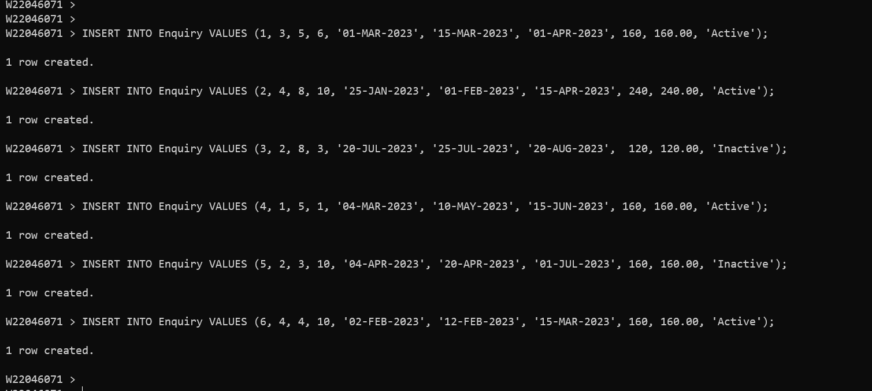

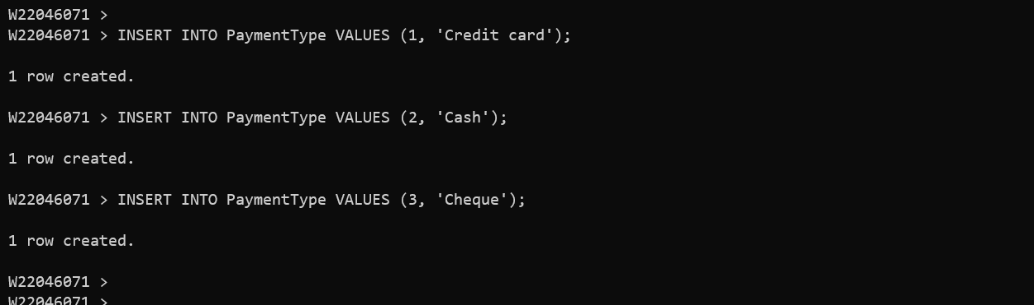

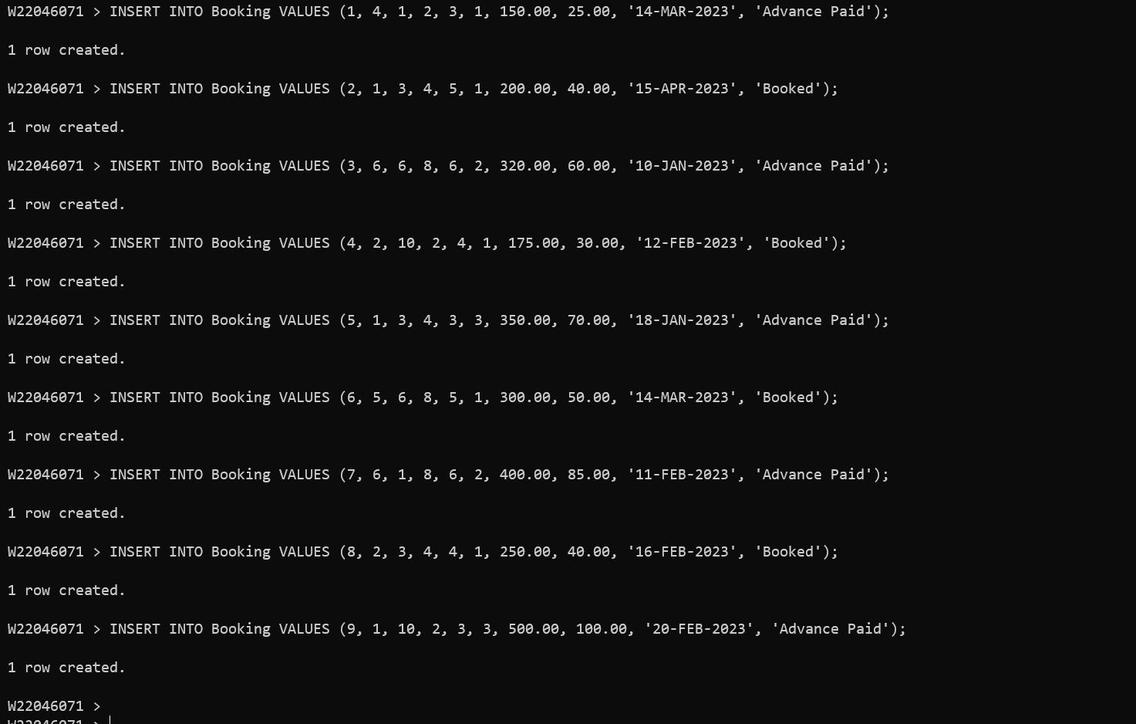

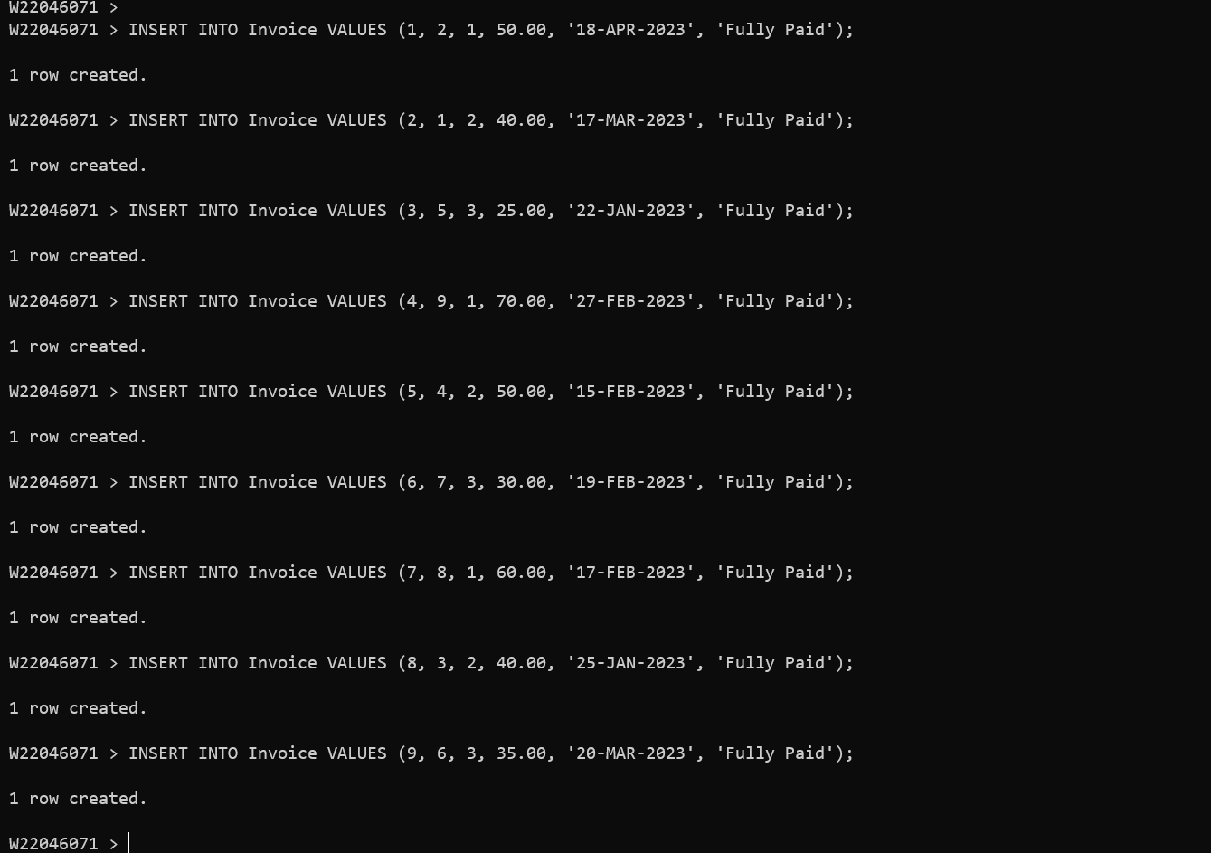

*(B) Answer the following queries (retrievals) using SQL and relational algebra.*

(20 marks)

Q1 ) Display details of clients, their sites and whatever security arrangements they have for their sites in Newcastle upon Tyne for the months of January, February and March 2023.

Answer Part 2 B (1): Relational Algebra Expression: 3 marks

πName, SiteName, ArrangementType, Description, StartDate, EndDate (σAddress=’Newcastle upon Tyne’AND (StartDate BETWEEN ‘01-JAN-2023’ AND ‘31-MAR-2023’ OR EndDate BETWEEN ‘01-JAN-2023’ AND ‘31-MAR-2023’)(Client ⨝ Site ⨝ Enquiry ⨝ SecurityArrangement))

Answer Part 2 B (1): SQL code [as simple TEXT]: 5 marks

SELECT c.Name, s.SiteName, sa.ArrangementType, sa.Description, e.StartDate, e.EndDate

FROM Client c

INNER JOIN Site s ON c.ClientID = s.ClientID

INNER JOIN Enquiry e ON s.SiteID = e.SiteID

INNER JOIN SecurityArrangement sa ON sa.ArrangementID = e.ArrangementID

WHERE s.Address = 'Newcastle upon Tyne'

AND (e.StartDate BETWEEN '01-JAN-2023' AND '31-MAR-2023' OR e.EndDate BETWEEN '01-JAN-2023' AND '31-MAR-2023');

Answer Part 2 B (1): SQL code output (should be image / screenshot): 2 marks

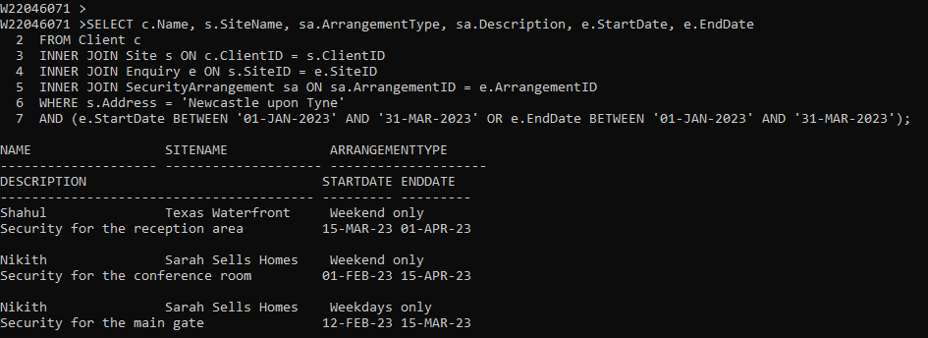

Q2 ) Display details of the client(s) who brought the most business in terms of most money paid to *NorthEastNinjas* during 2023.

Answer Part 2 B (2): Relational Algebra Expression: 3 marks

π c.Name, SUM(b.TotalAmount) (σ b.BookingDate BETWEEN '01-JAN-2023' AND '31-DEC-2023' (Client ⨝ Booking)) ⊕ (Σ SUM(b.TotalAmount) c.Name)

Answer Part 2 B (2): SQL code [as simple TEXT]: 5 marks

SELECT c.Name, SUM(b.TotalAmount) AS TotalAmount

FROM Client c

INNER JOIN Booking b ON c.ClientID = b.ClientID

WHERE b.BookingDate BETWEEN '01-JAN-2023' AND '31-DEC-2023'

GROUP BY c.Name

ORDER BY SUM(b.TotalAmount) DESC;

Answer Part 2 B (2): SQL code output (should be image / screenshot): 2 marks

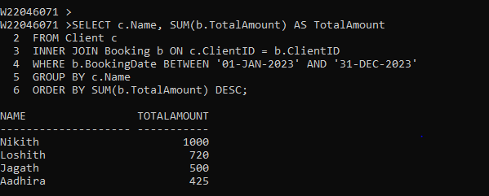

**Part 3 (20 marks)**

1. *Consider the NorthEastNinjas scenario in the Appendix. Produce a report for the CEO of the company elaborating on the professional, legal, security and ethical issues that need to be considered and make any recommendations that you think are appropriate for development and management of the database for NorthEastNinjas.*

(12 marks)

The report should be concise and comprehensive and in the region of 900-1000 words. You should use Harvard style of citation and referencing by following the guidelines in Pears and Shields (2008).

**Answer Part 3 (A): 12 Marks**

**[8 for the quality of report covering all the issues, 1 mark for the quality and range of literature used.**

**2 for the quality of referencing and citation and adhering to the Harvard style, 1 for presentation]**

**Professional issues:** The Security management companies deal with sensitive and confidential information such as access control procedures, surveillance techniques and client information which is needed to be safeguarded by NorthEast Ninjas Company. Maintaining confidentiality is critical to prevent breaches, data leaks, or other security risks and must comply with a wide range of assigned laws and rules along with regulations such as privacy laws, laws for data protection and employment laws. The companies make sure that their employees receive adequate training and development to stay up-to-date with new technologies and security risks. Negative publicity such as data breaches, security lapses, or unethical behaviour by employees, can damage the company's reputation and lead to loss of business (Decker, 2021).

**Recommendations:** The confidential information should be safeguarded and it should be maintained properly for preventing the data from data breaches, security risk and leakage of data. The laws for employment should be adopted by Northeast Ninjas Company for making the company’s name with high reputation.

**Legal issues:** All the companies underSecurity management must adapt with various regulations related to security and privacy. If the company fails to adapt with these regulations, then the company will suffer from fines, legal liabilities, and damage to the reputation of the company. In case of a security breach or data breach, the company may face legal claims and lawsuits for damages caused to the clients or third parties. The management companies must perform background checks on their employees to ensure they have no criminal history or other disqualifying factors. Failure to do so can result in negligent hiring lawsuits and other legal consequences. Security management companies must ensure that their services, software, and other intellectual property do not infringe on the rights of others. Failure to do so can result in intellectual property lawsuits and legal liabilities. Contractual disputes can arise if there are misunderstandings or breaches of the terms and conditions. Management companies regarding the security must follow with various laws of employment such as laws of wage and laws of hour, anti-discrimination laws and employee classification laws for employees. Failure to comply with these laws can result in legal claims and lawsuits (SHEMSHUCHENKO, 2020).

**Recommendations:** The NorthEast Ninjas Company should follow the lawsuits and follow rules and regulations for the security and privacy. The company should be aware of the employee’s real background and their originality in order to withstand the name, reputation and fame of the company. Various laws of employments should be strictly followed by the management of the company in order to overcome the lawsuits and legal claims. The NorthEast Ninjas Security Management Company must instruct all the employees to follow the rules framed by the company for the welfare of the company and also for the employees working there.

**Ethical issues:** Ethical issues can arise if employees misuse or disclose this information without authorization. The companies must ensure that their services and operations are free from bias and discrimination. The issues can arise if employees engage in discriminatory practices or if the company fails to take appropriate action to address discrimination complaints and if the use of force is excessive or unwarranted, or if employees engage in abusive behaviour. The companies may face conflicts of interest if they have business relationships or other ties with clients or third parties that compromise their impartiality or independence. If the company fails to disclose or address these conflicts of interest, various issues arise ethically (Jha, 2022).

**Recommendations:** The NorthEast Ninjas Company should be aware of the access and the data or information stored should be accessed only with proper authorisation. The employees should not misuse the information and should not access any data without authorisation as these misuses may lead to several issues in and around the company. The Company should follow the rules and regulations along with the services, functions and operations of the company which should be zero bias and discrimination. The company should ensure that all the employees working should follow the basic acts and they should not involve in abusive things which may affect the reputation and fame of the company. It also affects the employees working under the company due to these actions of abusive things done by some employees.

**Security issues**: The Company’s own physical assets such as its office, equipment, and vehicles are protected against theft, vandalism, or other physical threats. The Company’s systems should be secured against cyber threats such as hacking, data breaches and malware attacks. The Company must ensure that their access control systems are secure and effective in preventing unauthorized access by any employees inside the company and also the hackers from outside of the company. The surveillance systems of the company should also be secured and effective in detecting and preventing security breaches. It is very critical for the company to prevent insider threats and protect the confidentiality of clients' information. Therefore, the Company must have effective emergency response plans and procedures in place to protect their clients and employees (Singh, 2017).

**Recommendations:** The NorthEast Company should safeguard the properties of the company such as the office equipment, office vehicles or any basic physical threats. The information stored here should be secured form the Cyber-attacks such as hacking, data breaches and attack using malware. The company should keep track of the information stored and the information should be accessed only with proper and secured authorisation. Confidentiality and the systems of surveillance of the company should be ensured that the information stored should be protected and safeguard by the NorthEast Ninjas Company to avoid from cyber-attacks.

1. *Compare and contrast different approaches to database design (e.g., entity relationship modelling, normalisation, etc.) and briefly justify the approach you have used for answering Part 1 (A).*

(8 marks)

The report should be concise and comprehensive and in the region of 700-800 words. You should consult a range of literature (e.g., database textbooks, journal and conference articles, and quality websites). Again you should use Harvard style of citation and referencing by following the guidelines in Pears and Shields (2008).

**Answer Part 3 (B): 8 Marks [5 for the quality of comparison of the two approaches, 1 for the quality of referencing and citation and adhering to the Harvard style, 1 for presentation, 1 for choosing / justifying the approach used for part 1(A) ]**

**Differences between Normalization and Entity Relationship Modeling (ERM)**

|  |  |  |
| --- | --- | --- |
| **S.No** | **Normalisation** | **Entity Relationship modelling** |
| 1 | Normalisation is used for reducing data redundancy and improving data integrity by organizing data into separate tables | Entity Relationship Modelling helps in identifying and modelling the relationships between entities or objects in a database |
| 2 | The Logical design technique used by normalisation focuses on table structure, keys, and data types | The Conceptual design technique used by entity relationship modelling focuses on identifying entities and relationships between them without getting into details |
| 3 | Normalisation completely based on functional dependency and one column or group of columns determines another function | The relationships between entities are based on attributes and behaviours which was based on identifying and modelling |
| 4 | It completely based on rules for ensuring well-structured database with minimal redundancy and maximum data integrity | There are no equivalent set of rules but focuses on creating a clear and accurate model of entities and relationships |
| 5 | Normalization can be rigid and more difficult to modify once the database is established (Tutorialspoint, 202) | Entity Relationship modelling provides a more flexible approach to database design, allowing for changes to the model as requirements change over time |
| 6 | Normalization is often used for simpler systems or for optimizing data storage. | Entity Relationship modelling is often preferred for systems with complex relationships between data, such as in e-commerce, healthcare, or financial systems (Visual Paradigm, 2019) |
| 7 | The importance of the normalisation are the Improved data quality, consistency, and accuracy | Entity relationship modelling helps for improved data organization, data retrieval and maintenance |
| 8 | The main disadvantages of normalisation are increased complexity and requirement of additional joins | The entity relationship modelling can be time-consuming and may not capture all the system requirements |
| 9 | The main benefits of normalisation are that it ensures data integrity, minimizes redundancy and improves database performance | The main advantage of the entity relationship modelling is that it ensures data accuracy, consistency, and ease of maintenance |
| 10 | Modifying the database schema without affecting the data stored in it is therefore easier in normalisation (Peterson, 2019) | Identifying the entities, attributes, and relationships that exist in the system was done with the help of entity relationship modelling (Javatpoint, 2022). |

**JUSTIFICATION:**

Both the approaches of Entity Relationship modelling and normalization serve different purposes in database design and are essential for creating a well-structured and efficient database. ERM is a more flexible approach than the normalisation technique when gets focused on the relationships between entities, while normalization is a more rigid approach, focusing on reducing redundancy and improving data integrity. Choosing the appropriate approach depends on the specific requirements and goals of the database system being designed. All the database management systems company should use Entity Relationship modelling to get better results and goals.

Entity Relationship modelling helps to identify and model the relationships between entities or objects in a database. It provides a clear, graphical representation of the entities, their attributes, and their relationships. ERM is particularly useful for creating a conceptual model of the database, which can then be used to guide the logical and physical design phases and it allows designers to focus on the relationships between entities rather than the specifics of table structure and keys. ER modelling is used to design a database schema that represents the entities, attributes, and relationships in the system. This schema provides a blueprint for building a database that meets the system requirements. ER modelling can be used to integrate data from different sources into a single database. This is particularly useful in situations where data needs to be shared between different systems. ER modelling provides a common language for communicating database design requirements between developers, users, and stakeholders. This helps to make sure that the people involved in the process of database development process should have clear understanding regarding the requirements of the system (Javatpoint, 2022).

Normalization refers in processing the organized data into separate tables in order to reduce redundancy and for improving the integrity of the data. Functions in data anomalies such as insertion anomalies, update anomalies and deletion anomalies that occur when data is stored unstructured, can be eliminated by normalization. It also ensures that data is consistent and accurate, and it provides a framework for designing well-structured and efficient databases. According to the needs and requirements of the database, the design approaches are decided and used along with their specifications.

# References

Decker, D. W. J. a. B. C., 2021. A 30-Year Systematic Review of Professional Ethics and Teacher Preparation. [*https://doi.org/10.1177/0022466921989303*](https://doi.org/10.1177/0022466921989303)*,* p. pp.201–212.

Javatpoint, 2022. Difference between ER Model and Relational Model - javatpoint. [*https://www.javatpoint.com/er-model-vs-relational-model*](https://www.javatpoint.com/er-model-vs-relational-model)*.*

Jha, S., 2022. Ethical issues In Business Management. [*https://doi.org/10.52184/isbrmj.v6i02.116*](https://doi.org/10.52184/isbrmj.v6i02.116)*,* p. 25–37.

Peterson, R., 2019. What is Normalization? 1NF, 2NF, 3NF & BCNF with Examples. [*https://www.guru99.com/database-normalization.html*](https://www.guru99.com/database-normalization.html)*.*

SHEMSHUCHENKO, Y. a. K. A., 2020. Legal Aspects of Corporate Management in the Context of International Law Rules. Journal of Advanced Research in Law and Economics. [*https://doi.org/10.14505/jarle.v11.4(50).38*](https://doi.org/10.14505/jarle.v11.4(50).38)*,* p. 1416.

Singh, A. a. G. M., 2017. Information Security Management Practices: Case Studies from India. Global Business Review. [*https://doi.org/10.1177/0972150917721836*](https://doi.org/10.1177/0972150917721836)*,* p. 253–271.

Tutorialspoint, 202. Difference between Normalization and Denormalization.. [*https://www.tutorialspoint.com/difference-between-normalization-and-denormalization*](https://www.tutorialspoint.com/difference-between-normalization-and-denormalization)*.*

Visual Paradigm, 2019. What is Entity Relationship Diagram (ERD)?. [*https://www.visual-paradigm.com/guide/data-modeling/what-is-entity-relationship-diagram/.*](https://www.visual-paradigm.com/guide/data-modeling/what-is-entity-relationship-diagram/)

**References & Bibliography**

Northumbria (2020) Academic Regulations for Taught Awards. Available at: <https://www.northumbria.ac.uk/about-us/university-services/student-library-and-academic-services/quality-and-teaching-excellence/assessment/guidance-for-students/> (Accessed: 27 January 2023).

Pears, R. and  Shields, G. (2008) *Cite them right: the essential referencing guide*.   
Newcastle upon Tyne: Pear Tree Books. Available at: <https://www.citethemrightonline.com/> (Accessed: 27 January 2023).